C PROGRAMMING TO FIND DUPLICATE VALUES IN AN ARRAY

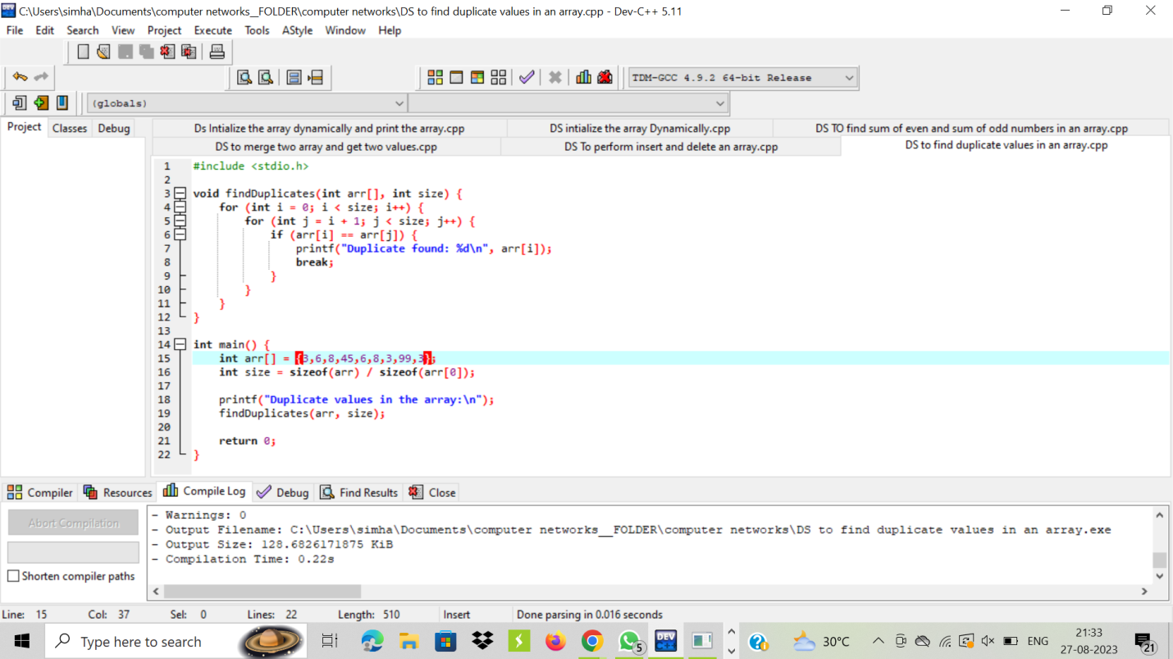

OUTPUT:

